Eagle free library
  - Report to the Community 2023
Library visits  2,279  Resident Borrowers  265  Live Programs  16  Total attendance for programs  605  Books circulated in 2023  2,836  Mini carnival was the most attended  90 plus kids and their parents | 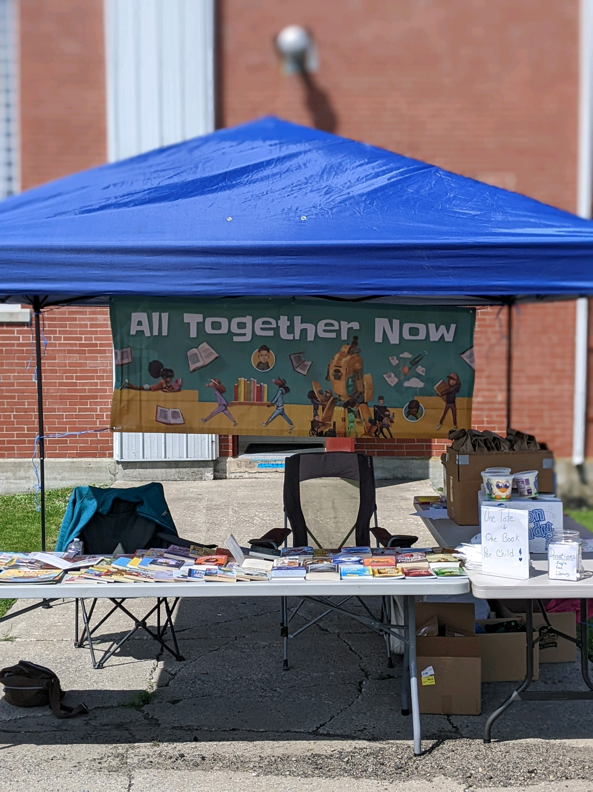

Thank you AES!
We received a generous grant from AES to update the Directors office and purchase 7 all new computers for our patrons and staff plus money toward our programs for next year. | 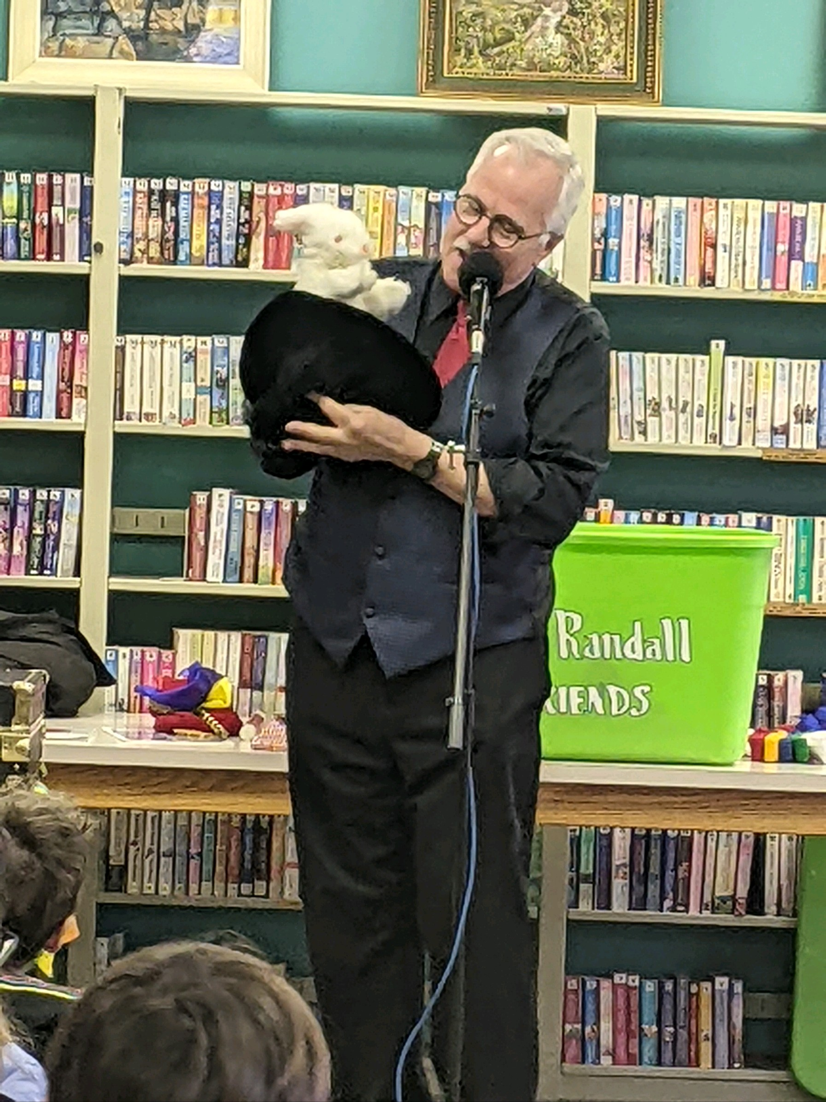
Board of Trustees:
Donna Barber-President
Louise Herrick-Acting Secretary
Raymond Kraft –Financial Officer
Linda Barber
Madonna Barber
Eleanor Ann Smith

Eagle Free Library

Jody Glaser/Director

