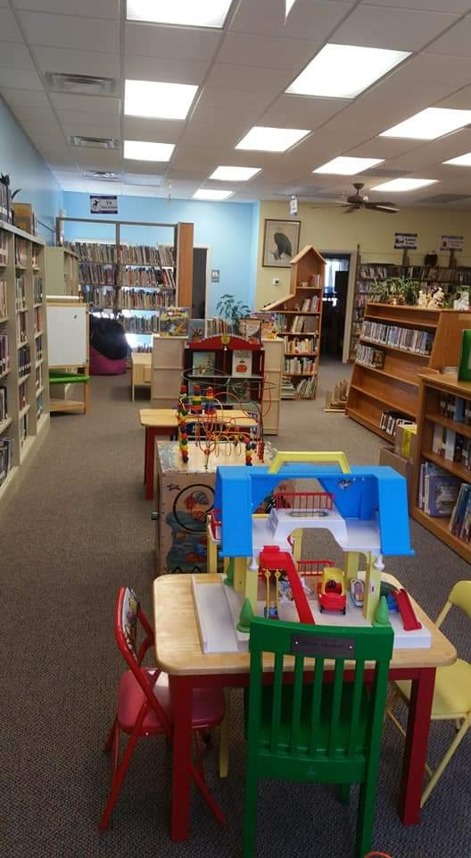  Eagle Free library yearly report 2021  Trustees:  Donna Barber-President  Cassandra Roberts-Secritary  Raymond Kraft-Treasurer  Ann Smith, Loise Herrick,  Linda Barber  Director: Jody Glaser  Event  Title Here  Event Description Heading  To get started right away, just tap any placeholder text (such as this) and start typing to replace it with your own. Want to replace the image above with something from Pickit? Just delete that image and select a new one from the Pickit pane on the right. | Back to Regular Hours  ────  Library visits: 1,343  --------  18 in person programs  Attended by 615 People  Total materials circulated: 3,441  1,844 Books circulated  Use and Retrieval of electronic information 1,325  Public computer use 473  Added 271 Cataloged Books  ────  We are Fine Free  ────  COVID masks and test kits are available at the front desk.  ────  Thank you to all our Patrons and volunteers!  Company Name  Street Address  City, ST ZIP Code  Telephone  Web Address  Dates and Times

