Eagle Free Library
Santa Night
Saturday, December 11th
from 6 to 7:40PM
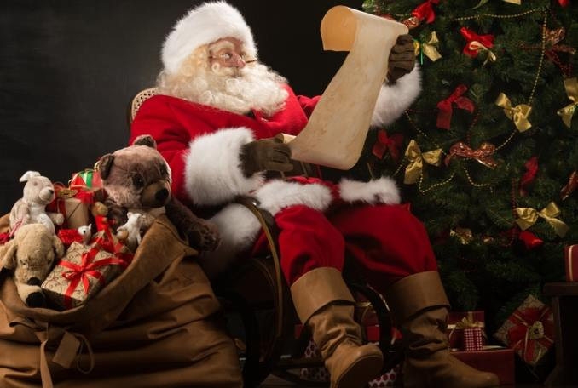
We will have time slots for people to register (12 children per time slot). Parents are of course welcome but please ONLY REGISTER CHILDREN. Kids will be able to talk to Santa and can take a photo with him. There will be no food or crafts or other activities in the library but kids will get goodie bags which will consist of a book, craft, candy cane, and other small goodies. Registration required.
Visit www.owwl.libcal.com to register.

